**TITLE: - BASIC GRAPHICS FUNCTION III**

**OBJECTIVE: -**

* To construct a bar graph (2D and 3D).
* To animate a moving bicycle.

**THEORY: -**

The “graphics.h” header in C and C++ programming provides several graphics function and allows to draw and animates several graphical objects in console. Some major graphics functions used in this operations are discussed below.

* bar(int left, int top, int right, int bottom): Draws a solid bar (rectangle) on the screen. The left and top parameters specify the coordinates of the top-left corner of the rectangle, while the right and bottom parameters specify the coordinates of the bottom-right corner.
* rectangle(int left, int top, int right, int bottom): Draws an outline rectangle on the screen. The left and top parameters specify the coordinates of the top-left corner of the rectangle, while the right and bottom parameters specify the coordinates of the bottom-right corner.
* circle(int centerX, int centerY, int radius): Draws a circle on the screen. The centerX and centerY parameters specify the coordinates of the center of the circle, while the radius parameter specifies the radius of the circle.
* line(int x1, int y1, int x2, int y2): Draws a line on the screen. The x1 and y1 parameters specify the coordinates of the starting point of the line, while the x2 and y2 parameters specify the coordinates of the ending point of the line.
* arc(int centerX, int centerY, int startAngle, int endAngle, int radius): Draws an arc (a portion of a circle) on the screen. The centerX and centerY parameters specify the coordinates of the center of the arc. The startAngle and endAngle parameters specify the start and end angles (in degrees) of the arc, and the radius parameter specifies the radius of the arc.
* bar3d(int left, int top, int right, int bottom, int depth, int topflag): Draws a three-dimensional bar (rectangular prism) on the screen.

**# WAP to draw bargraph(using bar() and bar3d()) and animated bicycle.**

#include<iostream>

#include<conio.h>

#include<graphics.h>

int xc,yc;

using namespace std;

void drawbox(int l, int b){

rectangle(xc-l,yc-b,xc+l,yc+b);}

void bargraph2d(){

system("cls");

float pixeldiv=20, scalediv=50, data=3, barwidth=30, bargap=20;//Sets the graph initializations

char yaxis[20]="Number", xaxis[20]="Year", title[50]="Bar Graph";

char name[5][20];

int value[5], i;

cout<<"\t\tEnter the graph details: "<<endl;

for(i=0;i<data;i++){

cout<<"\t\t\t*Enter the data head ["<<i+1<<"]:";

cin>>name[i];

cout<<"\t\t\t\t*Data Value: "; cin>>value[i];}

cleardevice();

outtextxy(xc-strlen(title),yc-210,title);

drawbox(300,200);

setcolor(2);

drawbox(302,202);

line(xc-220,yc+160,xc+270,yc+160);

line(xc-220,yc+160,xc-220,yc-160);

int px=xc-222, py=yc+140;

for(i=0;i<=15;i++){

char num[10];

itoa(scalediv*(i+1),num,10);

line(px,py,px+4,py);

outtextxy(px-strlen(num)*8,py-5,num);

py=py-pixeldiv;}

settextstyle(1,0,1);

outtextxy(xc+30,yc+180,xaxis);

settextstyle(1,1,1);

outtextxy(xc-280,yc-30,yaxis);

int xb=xc-200,yb=yc+160;

int lx=xc-220, ly=yc+160;

for(i=0;i<data;i++){

float height=(pixeldiv/scalediv)*value[i];

setfillstyle(1,i+1);

bar(xb,yb,xb+barwidth,yb-height);

line(lx,ly,xb+barwidth/2,yb-height);

lx=xb+barwidth/2;

ly=yb-height;

settextstyle(1,2,1);

outtextxy(xb+5,yb+10,name[i]);

xb=xb+barwidth+bargap;}}

void bargraph3d(){

system("cls");

float pixeldiv=20, scalediv=50, data=3, barwidth=30, bargap=20;//Sets the graph initializations

char yaxis[20]="Number", xaxis[20]="Year", title[50]="Bar Graph";

char name[5][20];

int value[5], i;

cout<<"\t\tEnter the graph details: "<<endl;

for(i=0;i<data;i++){

cout<<"\t\t\t*Enter the data head ["<<i+1<<"]:";

cin>>name[i];

cout<<"\t\t\t\t*Data Value: "; cin>>value[i];}

cleardevice();

outtextxy(xc-strlen(title),yc-210,title);

drawbox(300,200);

setcolor(2);

drawbox(302,202);

line(xc-220,yc+160,xc+270,yc+160);

line(xc-220,yc+160,xc-220,yc-160);

int px=xc-222, py=yc+140;

for(i=0;i<=15;i++){

char num[10];

itoa(scalediv*(i+1),num,10);

line(px,py,px+4,py);

outtextxy(px-strlen(num)*8,py-5,num);

py=py-pixeldiv;}

settextstyle(1,0,1);

outtextxy(xc+30,yc+180,xaxis);

settextstyle(1,1,1);

outtextxy(xc-280,yc-30,yaxis);

int xb=xc-200,yb=yc+160;

int lx=xc-220, ly=yc+160;

for(i=0;i<data;i++){

float height=(pixeldiv/scalediv)*value[i];

setfillstyle(1,i+1);

bar3d(xb,yb-height,xb+barwidth,yb,3,1);

line(lx,ly,xb+barwidth/2,yb-height);

lx=xb+barwidth/2;

ly=yb-height;

settextstyle(1,2,1);

outtextxy(xb+5,yb+10,name[i]);

xb=xb+barwidth+bargap;}}

void bicycle(int xc, int yc){

setfillstyle(1,2);

circle(xc-50,yc,30); // for the wheel (back)

circle(xc-50,yc,25);

circle(xc-50,yc,5);

circle(xc+50,yc,30); // for wheel (front)

circle(xc+50,yc,25);

circle(xc+50,yc,5);

circle(xc,yc-5,13); // for the middle ring

line(xc-50,yc-1,xc,yc-5); // connect the wheel

line(xc-50,yc+1,xc,yc-3); // connect the wheel

line(xc-50,yc-5,xc,yc-18); //for chain

line(xc-50,yc+5,xc,yc+8);

line(xc-1,yc-4,xc+9,yc+14); // for paddle

line(xc+1,yc-4,xc+7,yc+14);

ellipse(xc+8,yc+14,0,360,5,3);

line(xc-1,yc-5,xc-21,yc-45); //joins middle wheel back

line(xc+1,yc-5,xc-19,yc-45);

line(xc-1,yc-5,xc+30,yc-45); //middle to front

line(xc+1,yc-5,xc+32,yc-45);

line(xc-51,yc,xc-21,yc-45); //joins back wheel

line(xc-49,yc,xc-19,yc-45);

line(xc+49,yc,xc+24,yc-65); //joins front wheel

line(xc+51,yc,xc+26,yc-65);

line(xc-21,yc-44,xc+30,yc-44); //for the middle bar

line(xc-21,yc-46,xc+30,yc-46);

line(xc-21,yc-45,xc-21,yc-50); //for seat

line(xc-19,yc-45,xc-19,yc-50);

setfillstyle(1,2);

ellipse(xc-20,yc-52,0,360,12,3);

line(xc-51,yc,xc-60,yc-40); //back seat

line(xc-49,yc,xc-58,yc-40);

line(xc-59,yc-41,xc-25,yc-36);

line(xc-59,yc-39,xc-25,yc-34);

rectangle(xc-75,yc-44,xc-45,yc-42);

ellipse(xc-60,yc-42,0,360,15,3);

line(xc+10,yc-69,xc+38,yc-61); //for handle

line(xc+10,yc-67,xc+38,yc-63);

delay(1);

cleardevice();

}

int main(){

int gm=DETECT, gd=0;

initgraph(&gm,&gd,"..\\bgi");

xc=getmaxx()/2;

yc=getmaxy()/2;

main:

system("cls");

cout<<"LIST OF PROGRAMS"<<endl;

cout<<"[1]. Generate a BARGRAPH 2D"<<endl;

cout<<"[2]. Generate a BARGRAPH 3D"<< endl;

cout<<"[3]. Bicycle ANIMATION"<<endl;

cout<<"[4]. EXIT"<<endl;

cout<<"Enter the choice: ";

char a=getch();

switch(a){

case '1':{

system("cls");

bargraph2d();

getch();

cleardevice();

goto main;

}

case '2':{

system("cls");

bargraph3d();

getch();

cleardevice();

goto main;

}

case '3':{

system("cls");

while(!kbhit()){

bicycle(xc,yc);

xc=xc+1;

if(xc>getmaxx()-20)

xc=0;

if (kbhit()) {

system("cls");

cleardevice();

goto main;

}}}

case '4':{

system("cls");

exit(0);

}

default:{

system("cls");

cleardevice();

goto main;

}}}

**OUTPUT**: -

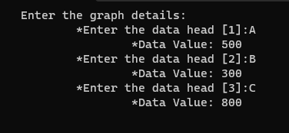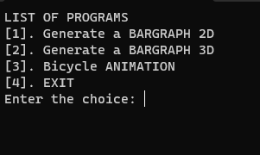

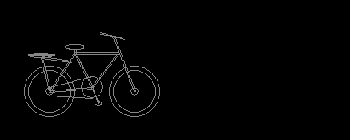



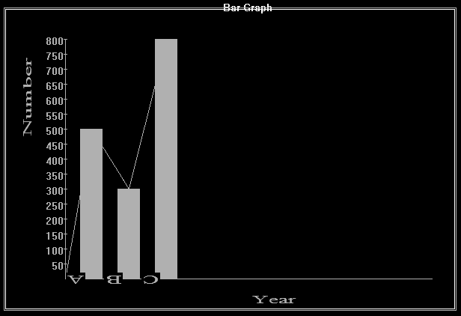

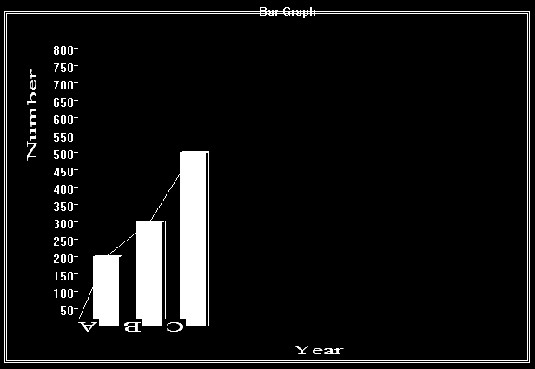

**CONCLUSION**: -

In conclusion, In summary, the graphics.h library is a graphics library used in older versions of C and C++. It provides functions for drawing basic shapes such as lines, rectangles, circles, and ellipses. Additionally, it allows for displaying text on the screen. However, it's important to note that graphics.h is specific to certain compilers and operating systems, and newer graphics libraries are typically used for modern graphics programming.